1.Issue a proper request to retrieve the contents of the index.html page. Replicate what the browser does.

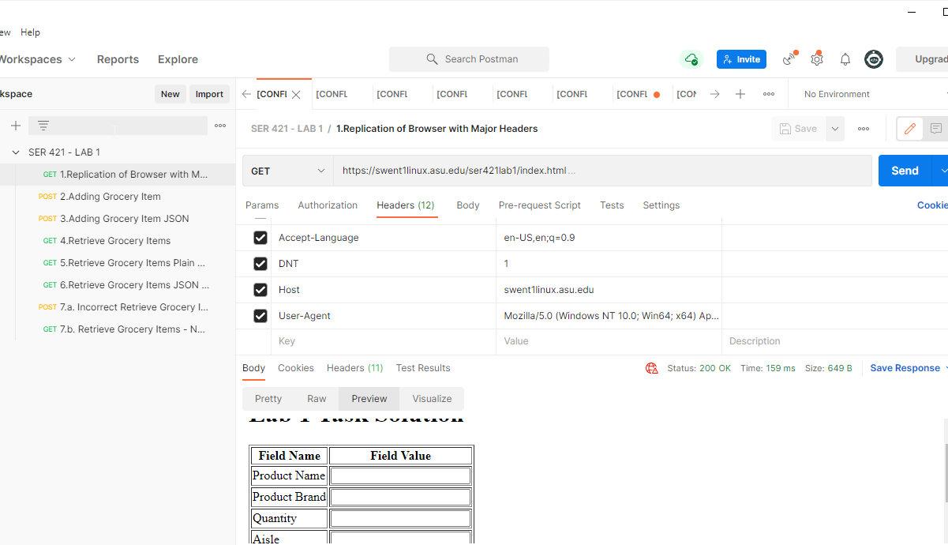

A proper request is issued replicating the headers of chrome browser.

The response html is in text file is attached below.



2. Issue a proper request to create a new grocery item (just like the results of submitting the form). You may create any item you like, but you should name the Product your asurite id. As you may try this more than once you may append a counter number at the end. For example, I would create products kgary1, kgary2, kgary3, etc.

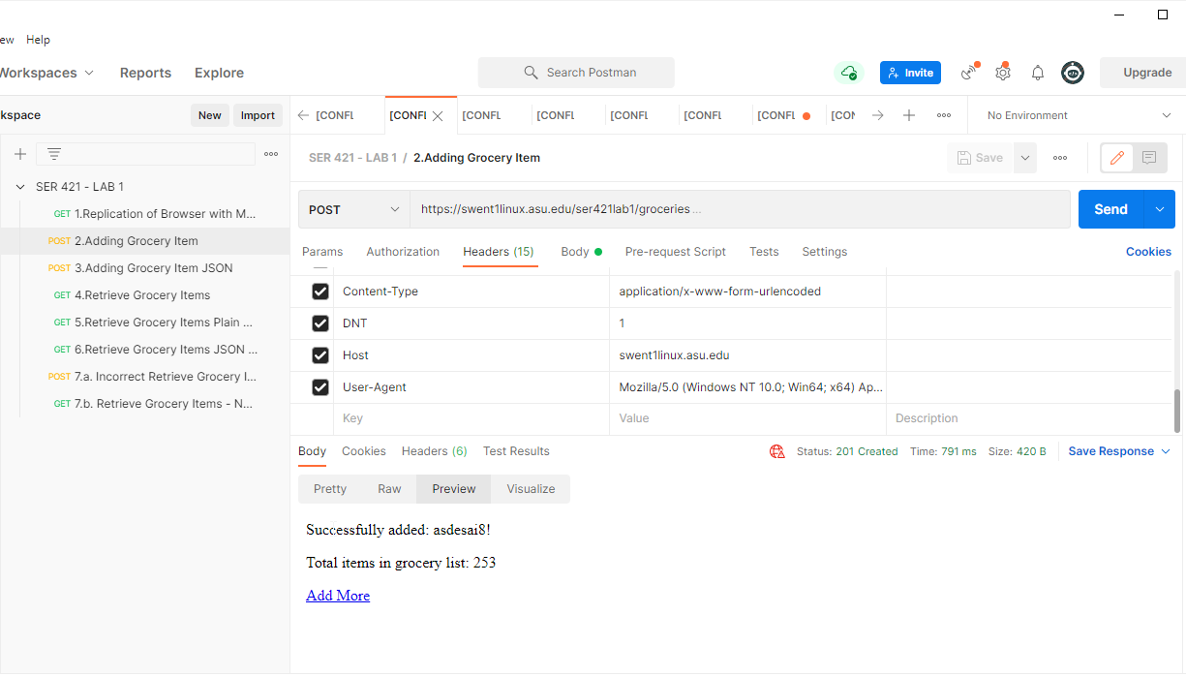

The post query is executed with the data sent in x-www-form-url-encoded format with corresponding value for header - Content/Type selected.

The response html is in text file is attached below



3. Repeat #2 but this time indicate the payload is in JSON, and construct the proper JSON (Note: The JSON payload is simply name-value pairs using the same parameter names in the HTML form).

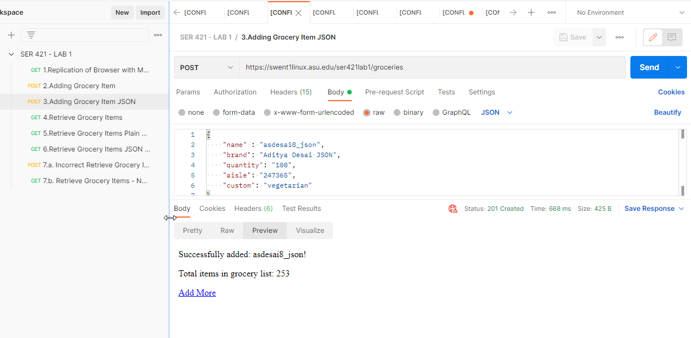

The post query is executed with the data sent in json format with corresponding value for header - Content/Type selected.

The response html is in text file is attached below



4. Issue a proper request to retrieve all grocery items in the grocery list as html

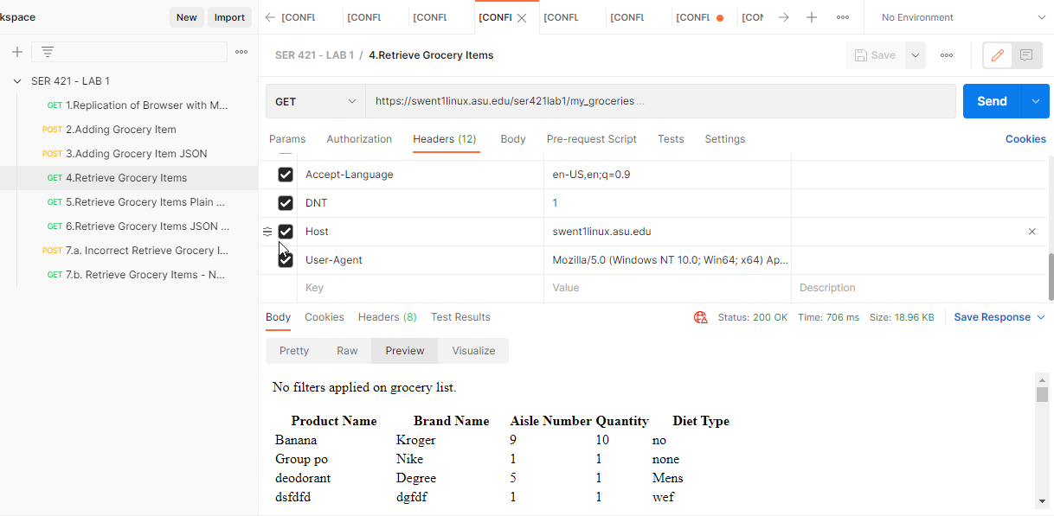

The get query is executed with the no request parameters and no modification to accept header.

The response html is in text file is attached below

5. Issue a proper request to retrieve only those grocery items in aisle 3 and indicate you want the results as plain text.

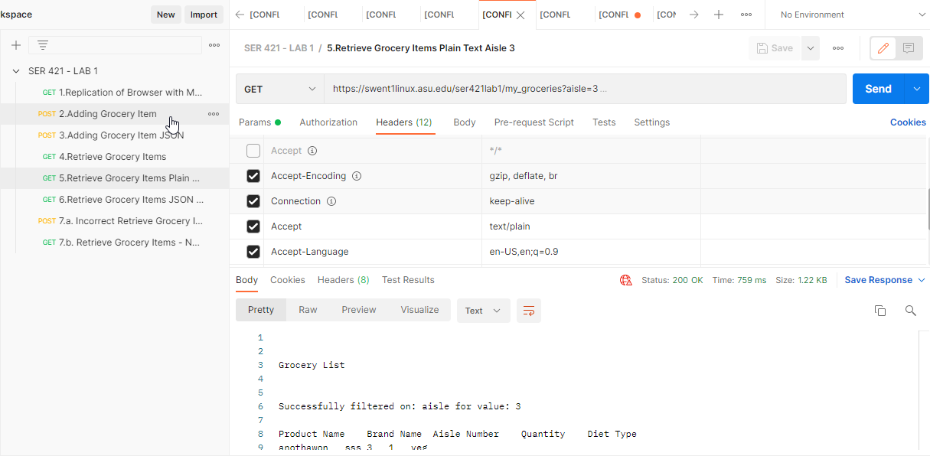

The get query is executed with the request parameters as aisle=3 and accept header having value text/plain.

The response html is in text file is attached below



6. Issue a proper request to retrieve only those grocery items in aisle 3 that are in a “veg” diet and indicate you want the results as JSON

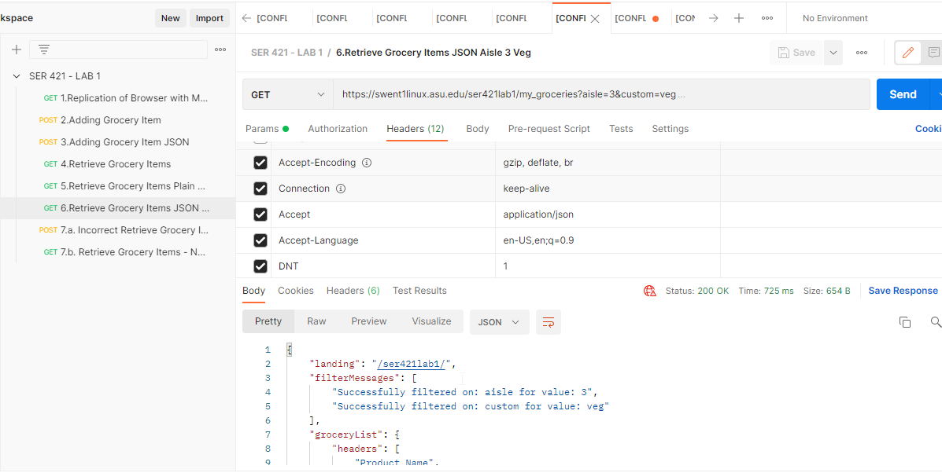

The get query is executed with the request parameters as aisle=3 and custom=veg and accept header having value application/json.

The response html is in text file is attached below



7.a. Issue a syntactically *incorrect request* to retrieve grocery items. You determine the request and capture the results.

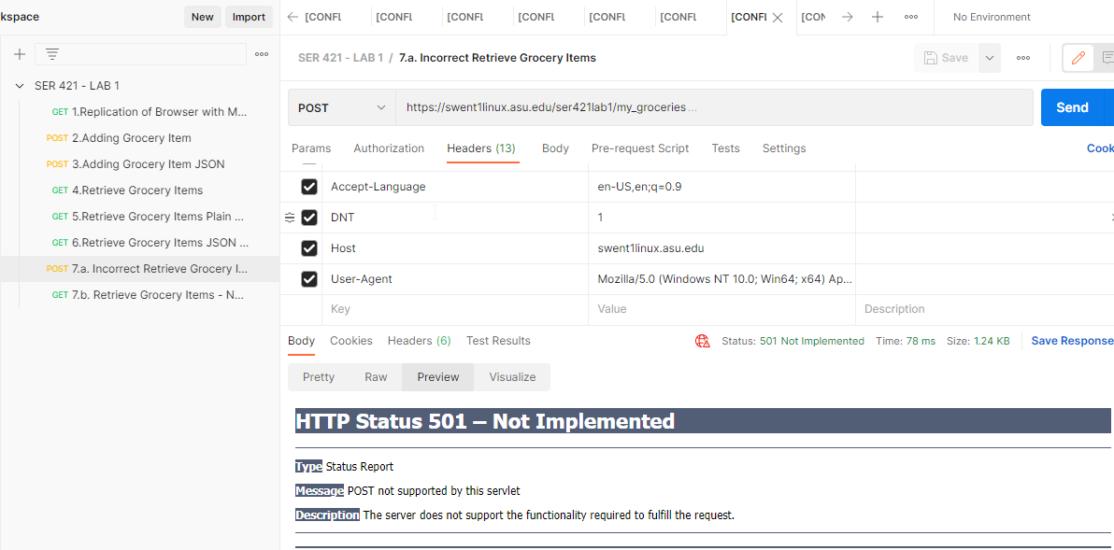

The query is executed with the no modification headers.

However the syntax of request is modified by instead of sending a get request, the query is executed with a post request.

This request gives error 501 response as the server expects a get query and not a post query for given resource



7.b Please delete entirely the header you used to indicate the desired results format in queries 4-6.

You determine the request and capture the results.

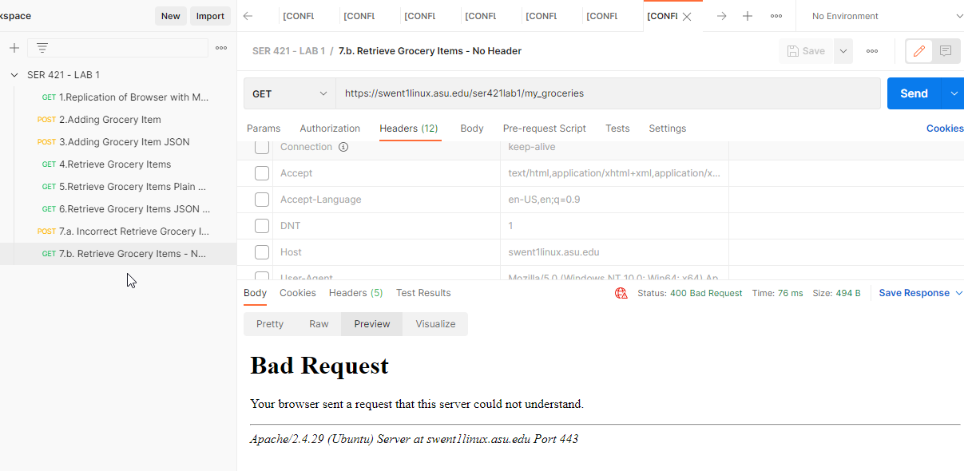

The get query is executed with the no headers.

Here, the server doesn't get **host** header and is unable to resolve where the request is to be routed.

Thus, the server treats it as a bad request and sends a corresponding 400 error response attached below.

